 | INDIAN SCHOOL AL WADI AL KABIR |  | 
Class: XI | Department: SCIENCE 2025 – 26  SUBJECT: CHEMISTRY |  | Date: 29/10/2025
Worksheet No: 6  WITH ANSWERS | CHAPTER: Organic Chemistry: Some basic principles and techniques |  | Note:  A4 FILE FORMAT
NAME OF THE STUDENT |  | CLASS & SEC: | ROLL NO.

1. | - Which of the following carbocations has the least stability?  - Methyl (b) ethyl (c) isopropyl (d) tert-butyl
2. | - IUPAC name of CH₃CH(OH)CH₂CH₂CH₂CH₂NH₂ is ………….  (a) 1-Amino-5-hydroxyhexane  (b) 2-Hydroxyhexan-1-amine  (c) 1-Aminohexan-5-ol  (d) 6-Aminohexan-2-ol
3. | - The structural formula for 2-Ethylprop-2-en-1ol  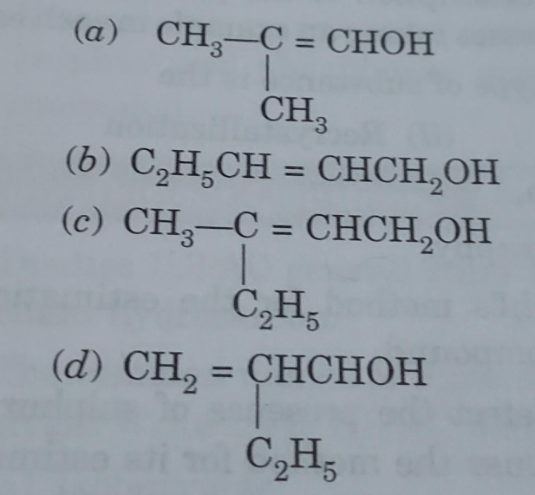
4. | The shape around carbon in Methanal is …….  (a) tetrahedral  (b) trigonal planar  (c) linear  (d) trigonal pyramidal
5. | 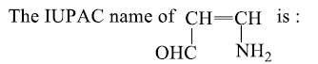  (a) 1-amino prop-2-enal  (b) 3-amino prop-2-enal  (c) 1-amino-2-formylethene  (d) 3-amino-1-oxoprop-2-ene
6. | Identify Isobutyl from the following.
7. | Detection of sulphur in sodium extract is done by  (a) Lead acetate (b) Sodium nitroprusside  (c) Both (a) and (b) (d) None of these
8. | Which of the following represents the correct order of decreasing priority?  (a) Aldehyde > Amine > Ketone  (b) Ketone > Aldehyde > Amine  (c) Aldehyde > Ketone >Amine  (d) Ketone > Amine > Aldehyde
9. | 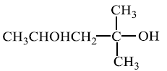  The IUPAC name for  a) 1,1-dimethyl-1,2-butanediol  b) 2-methyl-2,4-pentanediol  c) 4-methyl-2,4-pentanediol  d) 1,3,3-dimethyl-1,3-propanediol
10. | 2-Methylbutane and 2,2-Dimethylpropane are ……….  (a) Metamers  (b) Chain isomers  (c) Position isomer  (d) Functional group isomer
Assertion reasoning Questions
DIRECTION: In the following questions, a statement of assertion (A) is followed by a statement of reason (R). Mark the correct choice as:
(a) Both assertion (A) and reason (R) are true and reason (R) is the correct explanation of assertion (A).
(b) Both assertion (A) and reason (R) are true but reason (R) is not the correct explanation of assertion (A).
(c) Assertion (A) is true but reason (R) is false.
(d) Assertion (A) is false but reason (R) is true.
(e) Both Assertion and Reason are false.

11. | Assertion (A) : Simple distillation can help in separating a mixture of propan-1-ol  (boiling point 97°C) and propanone (boiling point 56°C).  Reason (R) : Liquids with a difference of more than 20°C in their boiling points can be  separated by simple distillation.
12. | Assertion (A): Energy of resonance hybrid is equal to the average of energies of all  canonical forms.  Reason (R) : Resonance hybrid cannot be presented by a single structure.
13. | Assertion: Ethanoic acid and Methyl methanoate are functional group isomers.  Reason: Ethanoic acid and Methyl methanoate have same molecular formula but  different functional groups.
14. | The electron displacements due to the influence of an atom or a substituent group  present in the molecule cause permanent polarisation of the bond (called electronic effect),  e.g.  In above example, polar C—F bond induce polarity in the adjacent bonds. Such polarisation  of adjacent σ- bond is referred to as the inductive effect. This effect decreases rapidly as the  number of intervening bonds increases. The resonance effect is defined as the polarity  produced in the molecule by the interaction of two π-bonds or in conjugated system.  When the group or atom release electron density then electron density of conjugated  system increases while the group or atom attract/withdraw electron density then electron  density of conjugated system decreases. Chloroacetic acid (ClCH₂COOH) is more acidic than acetic acid (CH₃COOH). This difference in acidity can be explained by the inductive effect of the chlorine atom. The chlorine atom, being electronegative, withdraws electron density through the σ-bonds, making the O-H bond more polar and easier to break.
- Which of the following system show abnormal behaviour in their properties (like stability, polarity ... etc.)?

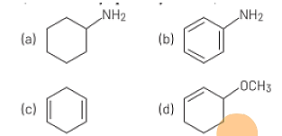

- What is meant by the Inductive effect?
- Explain why chloroacetic acid is a stronger acid than acetic acid using the concept of inductive effect
- Predict and justify whether trichloroacetic acid (CCl₃COOH) would be stronger or weaker than chloroacetic acid
 | - Very Short answer type questions
15. | Select electrophiles out of the following:  H⁺, Na⁺, Cl–, AlCl₃, CN–, CH₃CH₂⁺
16. | Write the IUPAC name of the following compound.  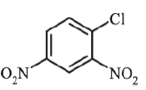
17. | Select nucleophiles from the following.  BF₃, NH₃, OH–, H₃O⁺, CN–.
18. | What is meant by resonance stabilisation energy?
 | Short answer type questions
19. | Describe the method of column chromatography
20. | Explain how is the electronegativity of carbon atoms related to their state of hybridisation in an organic compound
21. | Draw the resonance structures of Aniline.
22. | If a liquid compound decomposes at its boiling point, which method can you choose for its purification? Why? It is known that the compound is stable at low pressure, steam volatile and insoluble in water.
23. | Describe the qualitative analysis of Nitrogen and Sulphur.
 | Long answer type questions
24. | Explain the principle of steam distillation.
25. | a) (a) Draw the resonance structures of Nitrobenzene.  c) Define Hyperconjugation. Explain the Hyperconjugations in Propene.
26. | What are reaction intermediates? How are they generated by bond fission?

Q No | Answers
1 | - Methyl
2 | (d) 6-Aminohexan-2-ol
3 | 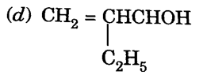
4 | (b) trigonal planar
5 | (b) 3-amino prop-2-enal
6
7 | (c) Both (a) and (b)
8 | (c) Aldehyde > Ketone >Amine
9 | b) 2-methyl-2,4-pentanediol
10 | (b) Chain isomers
11 | (a) Both A and R are true and R is the correct explanation of A
12 | (d) Assertion (A) is false but reason (R) is true.
13 | (a) Both A and R are true and R is the correct explanation of A
14 | - 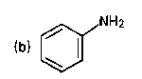  - The inductive effect is the permanent displacement of electrons through a sigma bond chain in a molecule due to differences in electronegativity between bonded atoms.  - Chloroacetic acid is a stronger acid than acetic acid because the electronegative chlorine atom exerts an electron-withdrawing inductive effect (-I). This effect pulls electron density away from the carboxylate group, making the proton easier to release compared to acetic acid.  - Trichloroacetic acetic acid is stronger than chloroacetic acid because the three chlorine atoms in trichloroacetic acid have a greater electron-withdrawing effect than the single chlorine atom in chloroacetic acid
15 | H⁺, Na⁺, AlCl₃, CH₃CH₂⁺
16 | 1-chloro-2,4-dinitrobenzene
17 | NH₃, OH–, CN–
18 | It is the difference in energy between the resonance hybrid and the most stable of the contributing resonance structures.
19 | Column chromatography involves separation of a mixture over a column of adsorbent (stationary phase) packed in a glass tube. The mixture is placed on the top of the adsorbent column packed in a glass tube. An appropriate eluent, which is a liquid, is allowed to flow down the column slowly. Depending upon the degree to which the compounds are adsorbed, complete separation takes place. The most readily adsorbed substances are retained near the top and others come down to various distances in the column.
20 | The electronegativity of a carbon atom increases with its percent 's' character in the hybridization, meaning an sp-hybridized carbon is the most electronegative, followed by sp²-hybridized, and then sp³-hybridized carbon is the least electronegative
21 | 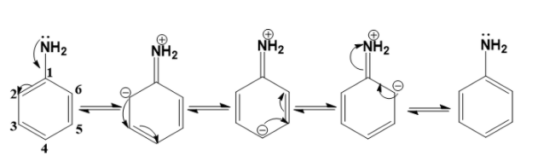
22 | You can use steam distillation to purify the compound because it is steam volatile, insoluble in water, and decomposes at its boiling point. Steam distillation allows the compound to be purified at a temperature lower than its decomposition point by using the vapor pressure of steam.
23 | Nitrogen  Experiment  The sodium fusion extract is boiled with iron (II) sulphate and then acidified with  conc. H2SO4  Observation  Prussian blue colour  Sulphur  Experiment  The sodium fusion extract is acidified with acetic acid and lead acetate is added to it.  Observation  A black precipitate
24. | Steam distillation works on the principle that two immiscible liquids, like water and an oil, will boil at a temperature lower than the boiling point of each individual liquid. The combined vapor pressure of the immiscible liquids equals the atmospheric pressure at this lower boiling point, allowing heat-sensitive compounds to be vaporized and separated without decomposition. Steam is either passed through the mixture (external steam) or the mixture is boiled with water (internal steam) to carry the volatile components to a condenser.
25 | - Hyperconjugation involves delocalisation of σ electrons of C—H bond of an alkyl group directly attached to an atom of unsaturated system or to an atom with an unshared p orbital.
26 | Reaction intermediates are highly reactive, short-lived chemical species formed during a chemical reaction that are quickly consumed. They are generated through bond fission, which involves the breaking of a covalent bond. Homolytic fission breaks a bond evenly, creating a free radical (with one unpaired electron), while heterolytic fission breaks a bond unevenly, forming a carbocation (positively charged) and a carbanion (negatively charged).

Prepared by:  Ms Jenesha Joseph | Checked by:  HOD Science

